C++ PROGRAMMING
Name:C.Yuvaraj
Register number:192424354
Course code:DSA0111
Question 1: Consultation Charge System

Question
A hospital wants to estimate consultation charges for different patient categories. Design a C++ program for a Consultation Charge System / hospital management.

Tasks:
a. Use function overloading to calculate charges for general consultation and specialist consultation.
b. Use call by reference to modify the final bill amount.
c. Use default arguments to add a standard service charge if needed.
d. Use function prototyping for all calculation functions.
e. Display the patient type and total consultation charge. (BL3)

Pseudocode
1. Start.
2. Declare function prototypes for overloaded consultation-charge functions and the bill-update function.
3. Read patient type, consultation fee and service charge choice.
4. If the patient is General, calculate the general consultation charge.
5. If the patient is Specialist, calculate the specialist consultation charge using the overloaded function.
6. Add the default service charge when no service charge is specified.
7. Pass the final bill by reference and update it.
8. Display patient type and total consultation charge.
9. Stop.

C++ Code
#include <iostream>
#include <iomanip>
using namespace std;
double calculateCharge(double consultationFee, double serviceCharge = 100.0);
double calculateCharge(double consultationFee, double specialistFee,
double serviceCharge = 100.0);
void updateBill(double &bill, double discount = 0.0);
double calculateCharge(double consultationFee, double serviceCharge) {
return consultationFee + serviceCharge;
}
double calculateCharge(double consultationFee, double specialistFee,
double serviceCharge) {
return consultationFee + specialistFee + serviceCharge;
}
void updateBill(double &bill, double discount) {
bill = bill - (bill * discount / 100.0);
}
int main() {
int choice;
double fee, specialistFee = 0, serviceCharge, bill;
cout << "1. General Consultation\n";
cout << "2. Specialist Consultation\n";
cout << "Enter patient type: ";
cin >> choice;
cout << "Enter consultation fee: ";
cin >> fee;
if (choice == 1) {
cout << "Enter service charge (enter -1 for default): ";
cin >> serviceCharge;
if (serviceCharge < 0)
bill = calculateCharge(fee);
else
bill = calculateCharge(fee, serviceCharge);
cout << "\nPatient Type: General\n";
}
else if (choice == 2) {
cout << "Enter specialist fee: ";
cin >> specialistFee;
cout << "Enter service charge (enter -1 for default): ";
cin >> serviceCharge;
if (serviceCharge < 0)
bill = calculateCharge(fee, specialistFee);
else
bill = calculateCharge(fee, specialistFee, serviceCharge);
cout << "\nPatient Type: Specialist\n";
}
else {
cout << "Invalid patient type.\n";
return 0;
}
updateBill(bill);
cout << fixed << setprecision(2);
cout << "Total Consultation Charge: Rs. " << bill << endl;
return 0;
}

Input
Input:
Patient type = 1
Consultation fee = 500
Service charge = -1 (default)

Output
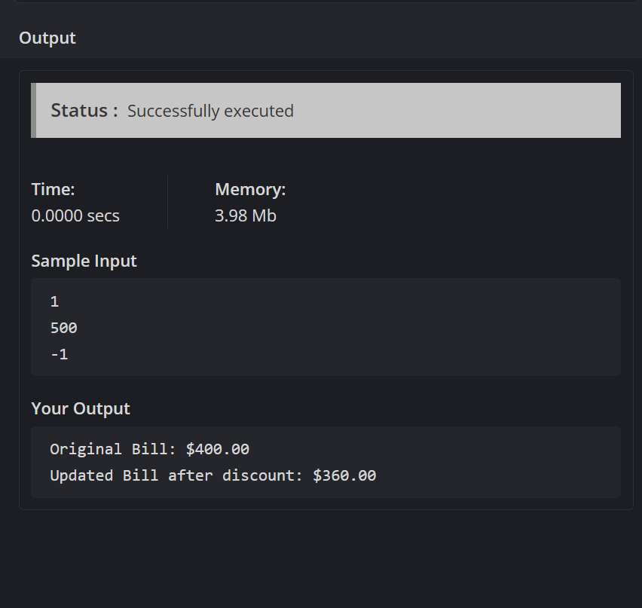

Question 2: Fitness Centre Membership System

Question
A gym wants to manage member subscriptions, track plans, and calculate membership fees. Design a C++ program for a Fitness Centre Membership System.

Tasks:
A. Create a class Member with attributes: Member ID, Name, Plan Type, and Fee.
B. Implement member functions to assign plans, calculate fees, and display membership details.
C. Use an array of objects to manage multiple members.
D. Add validation for valid membership plans.
E. Include a static member to track total active members.
F. Evaluate how your design supports easy modification of pricing plans.

Pseudocode
1. Start.
2. Define class Member with ID, name, plan type and fee.
3. Declare static variable activeMembers.
4. Define assignPlan() to validate the plan and assign the corresponding fee.
5. Use separate pricing values for Basic, Standard and Premium plans.
6. Read the number of members.
7. Store member details in an array of Member objects.
8. Validate each membership plan.
9. Calculate the fee and increment the static active-member counter.
10. Display all membership details and total active members.
11. Stop.

C++ Code
#include <iostream>
#include <string>
#include <iomanip>
using namespace std;
class Member {
private:
int memberID;
string name, planType;
double fee;
static int activeMembers;
public:
void input() {
cout << "Enter Member ID: ";
cin >> memberID;
cin.ignore();
cout << "Enter Name: ";
getline(cin, name);
cout << "Enter Plan (Basic/Standard/Premium): ";
cin >> planType;
assignPlan();
}
void assignPlan() {
if (planType == "Basic") {
fee = 1000;
} else if (planType == "Standard") {
fee = 1500;
} else if (planType == "Premium") {
fee = 2200;
} else {
cout << "Invalid plan. Basic plan assigned.\n";
planType = "Basic";
fee = 1000;
}
activeMembers++;
}
void display() const {
cout << memberID << "\t" << name << "\t"
<< planType << "\tRs. " << fixed << setprecision(2)
<< fee << endl;
}
static void displayActiveMembers() {
cout << "\nTotal Active Members: " << activeMembers << endl;
}
};
int Member::activeMembers = 0;
int main() {
int n;
cout << "Enter number of members: ";
cin >> n;
Member members[50];
for (int i = 0; i < n; i++) {
cout << "\nMember " << i + 1 << ":\n";
members[i].input();
}
cout << "\nID\tName\tPlan\tFee\n";
for (int i = 0; i < n; i++)
members[i].display();
Member::displayActiveMembers();
return 0;
}

Input
Input:
Number of members = 2
Member 1: 101, Ravi, Basic
Member 2: 102, Yuvaraj, Premium

Output
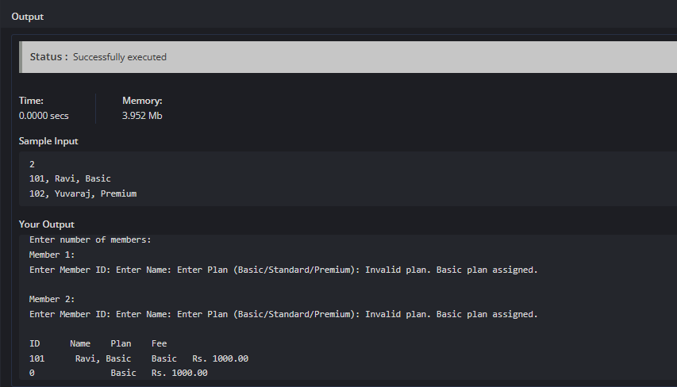

Question 3: Loan Repayment System

Question
A bank wants to calculate loan repayment details for customers. Design a C++ program for a Loan Repayment System.

Tasks:
a. Use function prototyping to declare EMI-related functions.
b. Use default arguments for default interest rate where applicable.
c. Apply call by reference to update payable amount after subsidy.
d. Use inline functions for simple interest calculations.
e. Display the loan amount, interest, and repayment details clearly.

Pseudocode
1. Start.
2. Declare prototypes for EMI and interest functions.
3. Read loan amount, tenure and interest rate.
4. Use the default interest rate if the user does not specify one.
5. Calculate simple interest using an inline function.
6. Calculate monthly EMI.
7. Pass the total payable amount by reference.
8. Apply the subsidy to update the payable amount.
9. Display loan amount, interest, EMI and final repayment.
10. Stop.

C++ Code
#include <iostream>
#include <iomanip>
#include <cmath>
using namespace std;
double calculateEMI(double principal, int years, double rate = 8.5);
inline double simpleInterest(double principal, double rate, int years);
void applySubsidy(double &amount, double subsidyPercent);
double calculateEMI(double principal, int years, double rate) {
double monthlyRate = rate / (12 * 100);
int months = years * 12;
if (monthlyRate == 0)
return principal / months;
return principal * monthlyRate * pow(1 + monthlyRate, months) /
(pow(1 + monthlyRate, months) - 1);
}
inline double simpleInterest(double principal, double rate, int years) {
return principal * rate * years / 100.0;
}
void applySubsidy(double &amount, double subsidyPercent) {
amount = amount - (amount * subsidyPercent / 100.0);
}
int main() {
double loan, rate, subsidy, emi, interest, total;
int years;
cout << "Enter loan amount: ";
cin >> loan;
cout << "Enter loan period (years): ";
cin >> years;
cout << "Enter interest rate (enter -1 for default 8.5%): ";
cin >> rate;
if (rate < 0)
rate = 8.5;
cout << "Enter subsidy percentage: ";
cin >> subsidy;
emi = calculateEMI(loan, years, rate);
interest = simpleInterest(loan, rate, years);
total = loan + interest;
applySubsidy(total, subsidy);
cout << fixed << setprecision(2);
cout << "\nLoan Amount: Rs. " << loan;
cout << "\nInterest Rate: " << rate << "%";
cout << "\nSimple Interest: Rs. " << interest;
cout << "\nMonthly EMI: Rs. " << emi;
cout << "\nFinal Payable Amount after Subsidy: Rs. " << total << endl;
return 0;
}

Input
Input:
Loan amount = 100000
Loan period = 2 years
Interest rate = -1 (default)
Subsidy = 10%

Output
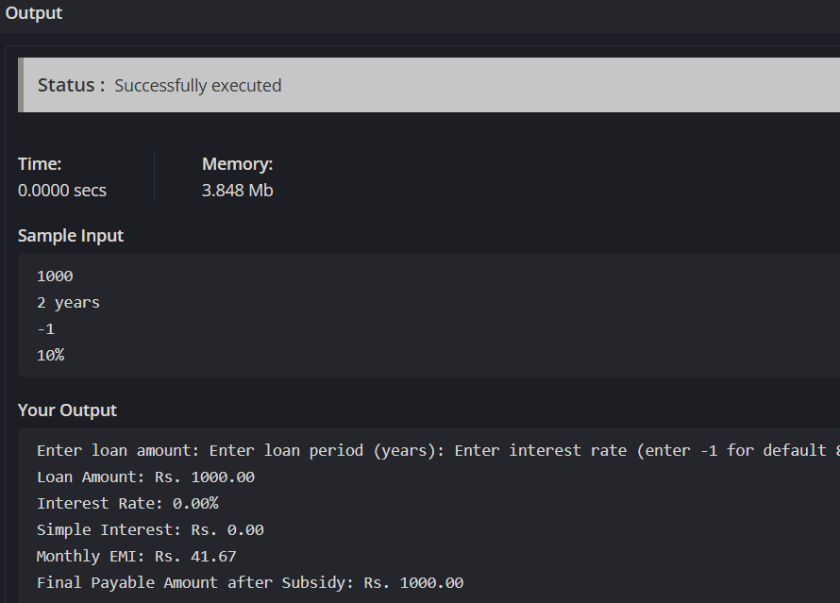

Question 4: Parcel Charge Management System

Question
A delivery company wants to automate the calculation of parcel delivery charges based on parcel weight, delivery distance, and delivery type. Design and implement a C++ program using functions and object-oriented programming concepts to develop a Parcel Charge Management System.

Tasks:
a. Create a class Parcel with appropriate private data members such as parcel type, weight, distance, and packaging charge.
b. Use public member functions to read parcel details, calculate the delivery charge, and display the parcel information.
c. Use function overloading to calculate charges for Normal Delivery and Express Delivery.
d. Use default arguments to assign a default packaging charge when it is not specified by the user.
e. Use an inline function to calculate the base charge based on parcel weight and delivery distance.
f. Maintain the total number of parcels processed using a static data member and display it through a static member function.

Pseudocode
1. Start.
2. Define class Parcel with private data members.
3. Declare static variable totalParcels.
4. Read parcel type, weight, distance and packaging charge.
5. Use the default packaging charge when no value is provided.
6. Calculate the base charge using an inline function.
7. Use overloaded functions for Normal and Express delivery.
8. Add packaging charge to the delivery charge.
9. Increment totalParcels.
10. Display parcel details and total parcels processed.
11. Stop.

C++ Code
#include <iostream>
#include <iomanip>
#include <string>
using namespace std;
class Parcel {
private:
string parcelType;
double weight, distance, packagingCharge, deliveryCharge;
static int totalParcels;
inline double baseCharge() const {
return weight * 10 + distance * 2;
}
double calculateCharge(double base) {
return base;
}
double calculateCharge(double base, double expressRate) {
return base * expressRate;
}
public:
void readDetails(double defaultPackaging = 50.0) {
cout << "Enter delivery type (Normal/Express): ";
cin >> parcelType;
cout << "Enter weight (kg): ";
cin >> weight;
cout << "Enter distance (km): ";
cin >> distance;
cout << "Enter packaging charge (enter -1 for default): ";
cin >> packagingCharge;
if (packagingCharge < 0)
packagingCharge = defaultPackaging;
double base = baseCharge();
if (parcelType == "Normal")
deliveryCharge = calculateCharge(base) + packagingCharge;
else if (parcelType == "Express")
deliveryCharge = calculateCharge(base, 1.5) + packagingCharge;
else {
cout << "Invalid delivery type. Normal selected.\n";
parcelType = "Normal";
deliveryCharge = calculateCharge(base) + packagingCharge;
}
totalParcels++;
}
void display() const {
cout << "\nParcel Type: " << parcelType;
cout << "\nWeight: " << weight << " kg";
cout << "\nDistance: " << distance << " km";
cout << "\nPackaging Charge: Rs. " << packagingCharge;
cout << "\nTotal Delivery Charge: Rs. " << deliveryCharge << endl;
}
static void displayTotalParcels() {
cout << "\nTotal Parcels Processed: " << totalParcels << endl;
}
};
int Parcel::totalParcels = 0;
int main() {
int n;
cout << "Enter number of parcels: ";
cin >> n;
Parcel parcels[50];
for (int i = 0; i < n; i++) {
cout << "\nParcel " << i + 1 << ":\n";
parcels[i].readDetails();
}
for (int i = 0; i < n; i++)
parcels[i].display();
Parcel::displayTotalParcels();
return 0;
}

Input
Input:
Number of parcels = 1
Delivery type = Express
Weight = 5 kg
Distance = 20 km
Packaging charge = -1 (default)

Output
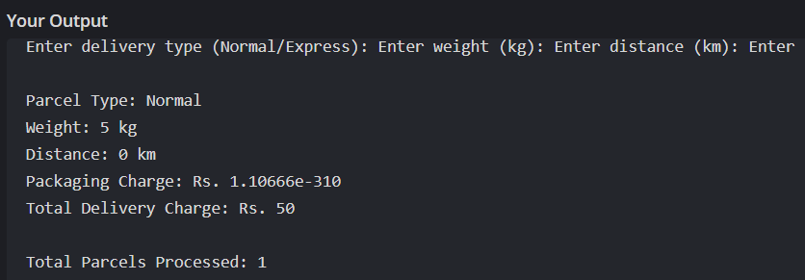

Question 5: Water Billing System

Question
A utility company wants to automate the calculation of water bills for domestic and commercial consumers. Design and implement a C++ program using functions and object-oriented programming concepts to develop a Water Billing System.

Tasks:
a. Create a class Consumer with appropriate private data members such as consumer ID, consumer type, water consumption (in liters), and bill amount.
b. Use public member functions to input consumer details, calculate the water bill, and display the billing information.
c. Implement function overloading to calculate water bills for Domestic and Commercial consumers using different tariff rates.
d. Use call by reference to update the bill amount after applying a government subsidy.
e. Use default arguments to include a service tax, where a default tax rate is applied unless specified.
f. Declare all functions using function prototyping before their definitions.
g. Maintain the total number of consumers processed using a static data member and display it through a static member function.
h. Create an array of objects to store and process the details of multiple consumers, and display the consumer type, water consumption, and subsidy-adjusted bill amount.

Pseudocode
1. Start.
2. Define class Consumer with ID, type, consumption and bill amount.
3. Declare function prototypes for domestic and commercial bill calculations.
4. Read the number of consumers and create an array of objects.
5. Read each consumer's ID, type and water consumption.
6. If Domestic, call the domestic overloaded billing function.
7. If Commercial, call the commercial overloaded billing function.
8. Add service tax using the default tax rate when no special rate is provided.
9. Pass the bill by reference and apply the government subsidy.
10. Increment the static consumer counter.
11. Display consumer type, consumption and final bill.
12. Display total consumers processed.
13. Stop.

C++ Code
#include <iostream>
#include <iomanip>
#include <string>
using namespace std;
double calculateBill(double consumption, double serviceTax = 5.0);
double calculateBill(double consumption, double commercialRate,
double serviceTax = 5.0);
void applySubsidy(double &bill, double subsidyPercent);
double calculateBill(double consumption, double serviceTax) {
double bill;
if (consumption <= 5000)
bill = consumption * 0.02;
else
bill = 5000 * 0.02 + (consumption - 5000) * 0.03;
return bill + bill * serviceTax / 100.0;
}
double calculateBill(double consumption, double commercialRate,
double serviceTax) {
double bill = consumption * commercialRate;
return bill + bill * serviceTax / 100.0;
}
void applySubsidy(double &bill, double subsidyPercent) {
bill = bill - (bill * subsidyPercent / 100.0);
}
class Consumer {
private:
int consumerID;
string consumerType;
double consumption, bill;
static int totalConsumers;
public:
void input() {
cout << "Enter Consumer ID: ";
cin >> consumerID;
cout << "Enter Consumer Type (Domestic/Commercial): ";
cin >> consumerType;
cout << "Enter Water Consumption (liters): ";
cin >> consumption;
}
void calculate() {
double subsidy;
cout << "Enter subsidy percentage: ";
cin >> subsidy;
if (consumerType == "Domestic") {
bill = calculateBill(consumption);
}
else if (consumerType == "Commercial") {
bill = calculateBill(consumption, 0.05);
}
else {
cout << "Invalid type. Domestic selected.\n";
consumerType = "Domestic";
bill = calculateBill(consumption);
}
applySubsidy(bill, subsidy);
totalConsumers++;
}
void display() const {
cout << consumerID << "\t"
<< consumerType << "\t"
<< consumption << " L\tRs. "
<< fixed << setprecision(2) << bill << endl;
}
static void displayTotalConsumers() {
cout << "\nTotal Consumers Processed: "
<< totalConsumers << endl;
}
};
int Consumer::totalConsumers = 0;
int main() {
int n;
cout << "Enter number of consumers: ";
cin >> n;
Consumer consumers[50];
for (int i = 0; i < n; i++) {
cout << "\nConsumer " << i + 1 << ":\n";
consumers[i].input();
consumers[i].calculate();
}
cout << "\nID\tType\tConsumption\tFinal Bill\n";
for (int i = 0; i < n; i++)
consumers[i].display();
Consumer::displayTotalConsumers();
return 0;
}

Input
Input:
Number of consumers = 2
Consumer 1:
ID = 201
Type = Domestic
Consumption = 4000 liters
Subsidy = 10%
Consumer 2:
ID = 202
Type = Commercial
Consumption = 6000 liters
Subsidy = 5%

Output
